IN ROSSO LE MODIFICHE

IN BLU COMMENTI MIEI, NON DA METTERE NELLA RELEASE

IN NERO VERSIONE ATTUALE

RASD--------------------------------------------------

goal 10 modificato,

G10: Allow only the user who reserved the car (and his passenger) to access it

Requirements:

* The system must be able to check the position of the user
* The system must allow the user to click the “unlock” button after he has reserved a car
* The system must not accept request of unlock if the user is more than 100 meters away from the car
* The system must unlock the car when he accepts the unlock request from the user
* The system must lock the car if no user enters the car within 60 seconds from the unlock request
* The system must lock the car if the user and all the passengers exit the car

class diagram modificato

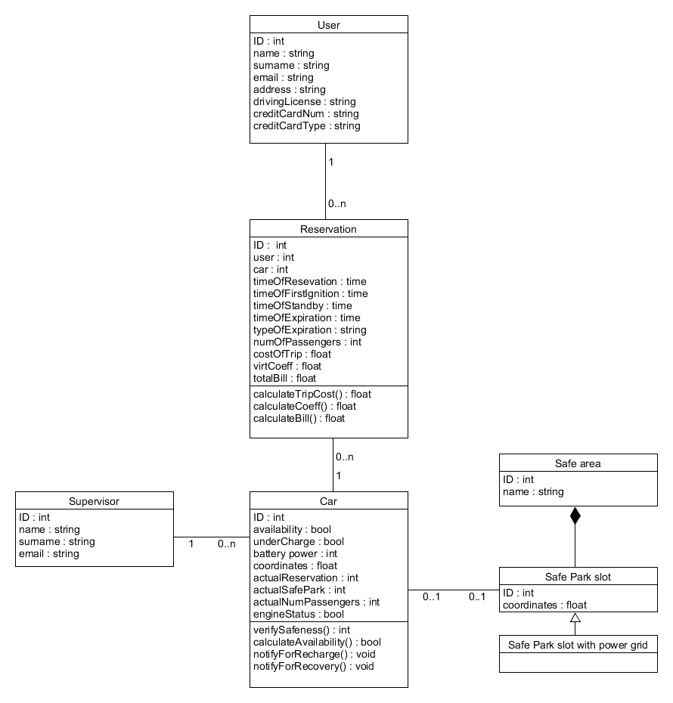

RESERVATION Statechart modificato

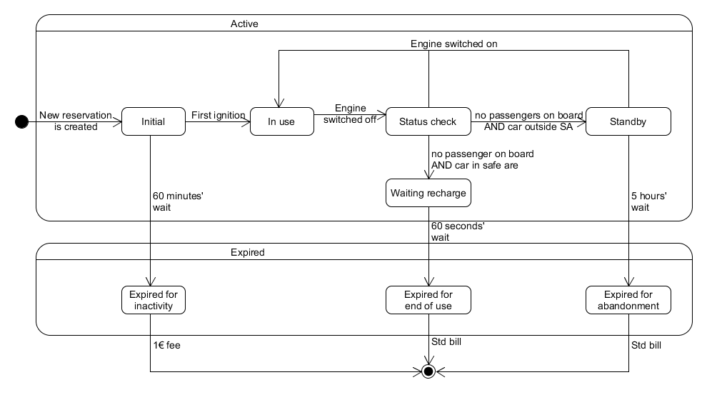

**Ultima ASSUMPTION modificata:**

**The screens on the car show the same infos showed on the “myReservation” page of the users’ app (duration of the trip, current cost of the trip), and a map with the suggested route to take (if the user selected the "money saving" option)**

GOAL 14 modificato receive con select, aggiunto un punto, nel quarto punto, la frase finisce dopo plug, togliere quello che c’è dopo:

G14: Support the users saving money

Requirements:

* The system must allow the user to select the “money saving” option when he reserves a car
* The system must allow the user to insert his destination after he select the money saving option
* The system must be able to recognize the place entered by the user
* The system must know the availability of each power plug -------
* The system must calculate the shortest path to the user’s destination, and display it on the screen of the car reserved by the user
* The system must calculate the nearest safe area to the user’s destination, with free power grids where to attach the car

DD-----------------------------------------------------

sotto al component diagram, nel NB aggiungere la frase:

DB run on the same server of the application server, so for simplicity we represented it as a normal component in the component diagram)

Sotto alla high level architecture, prima della component view, scrivere questo:

The communications between the central server and the mobile devices (user’s device and car’s devices) are performed using RESTful API through the mobile network (3/4g)